How to Setup ‘My Business Account’ with CRA (Canada Revenue Agency)

Please go to the following CRA website:
https://www.canada.ca/en/revenue-agency/services/e-services/e-services-businesses/business-account.html

Halfway down the page click on ‘CRA register’ as illustrated below.

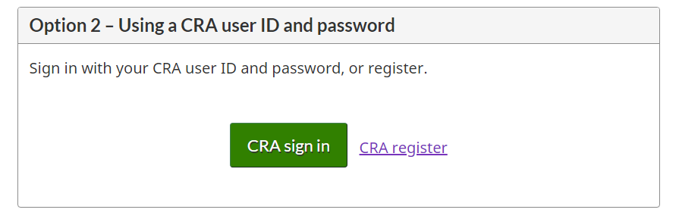
Follow the onscreen instructions to receive an access code.
**Please note you will need personal information for this step so make sure you have a copy of your most recent tax return on hand.

Once you receive your access code, follow the steps below to provide authorization for Rumley Holmes LLP.

1. Log into your CRA ‘My Business Account’ using the link provided above
2. Click on “Business Profile” (see the blue bar in the top middle part of the page)
3. Click "Manage Authorized Representatives"
4. Click “Authorize a representative”
5. Enter the Rumley Holmes business number: 827608233 then click "Next"
6. For "Authorization Level” select "2". Under expiration date, you can leave it blank (which means that authorization will continue until you cancel it), or you can set an expiry date. Select “All Accounts”. Click "next"
7. Click the "I confirm" checkbox, and hit "submit"

